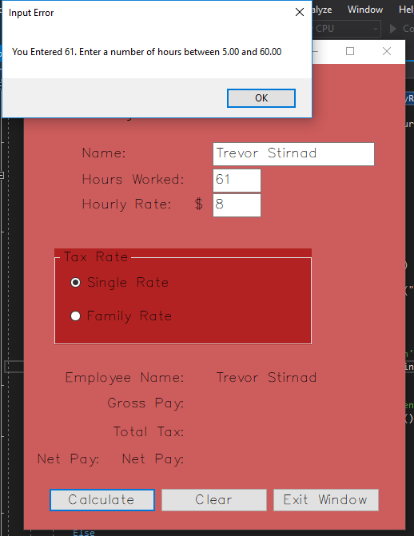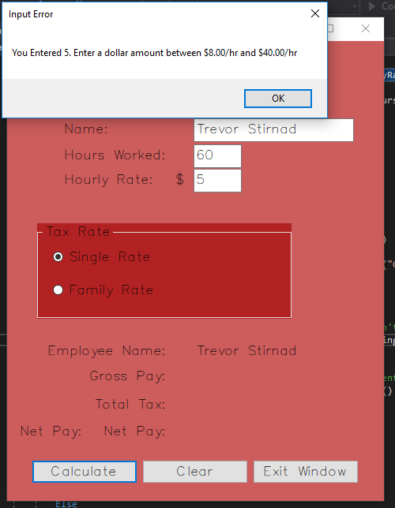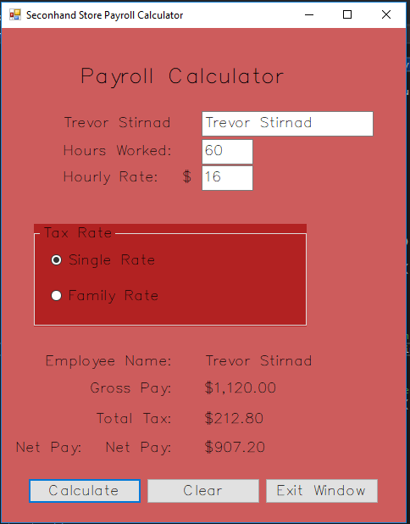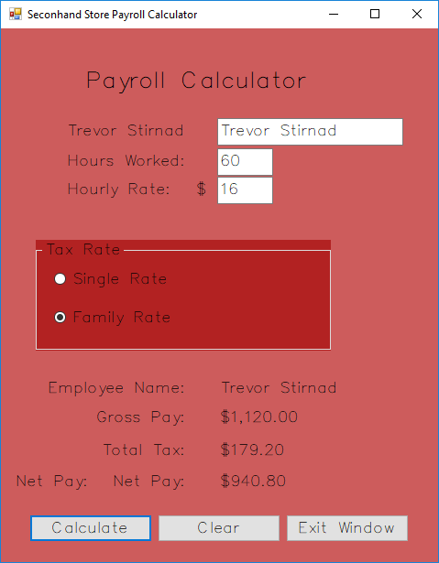

|  |  |  |  |
| --- | --- | --- | --- |
| **Program Name:** | **Developer:** | **Object:** | **Date**: |
| Secondhand Store Payroll Calculator | David Brungardt | frmPayroll Calculator | December 3, 2017 |
| **Object** | **Event Trigger** | **Event Processing** | |
| btnCalculate | Click | Ensure data entered is numeric  Display error message if hours worked is not between 5 and 60  Display error message if hourly rate isn’t between $8.00 and $40.00  Convert data entered to decimal  Ensure data entered is a positive number  Display error message if data is not a positive number  Assign tax rate based on which tax rate is selected (single or family)  Calculate gross pay (hours worked x hourly rate )  Calculate total taxes ( gross pay x selected tax rate )  Calculate net pay (gross pay – total taxes)  Calculate overtime if hours worked > 40 ((Hours worked + (Hours worked - 40) *0.5) * Hourly Rate | |
| btnClear | Click | Clear name textbox  Clear hours worked textbox  Clear hourly rate textbox  Clear name label  Clear Gross Pay label  Clear Total Taxes label  Clear Net Pay label  Set Single tax rate button to be checked  Clear the Family tax rate button  Set focus on name text box | |
| btnExit | Click | Close the window and terminate the program | |
| frmPayrollCalculator | Load | Set focus on input name box  Clear name label  Clear placement zeros for hours worked and hourly rate labels | |

' Program Name: Seconhand Store Payroll Calculator

' Author: David Brungardt

' Date: 12/03/2017

' Purpose: This windows application computes the

' gross pay, total tax and net pay for

' a seconhand store based on wage, hours

' worked, and tax rate (Single or Family)

Option Strict On

Public Class frmPayrollCalculator

Private Sub frmPayrollCalculator_Load(sender As Object, e As EventArgs) Handles MyBase.Load

' This event handler is executed when

' the form is loaded at the start of

' the program. It sets the focus

' to the Name text box and

' clears the Gross Pay, Total Tax

' and Net Pay labels.

txtName.Focus()

lblGrossPay.Text = ""

lblTotalTax.Text = ""

lblNetPay.Text = ""

End Sub

Private Sub btnClear_Click(sender As Object, e As EventArgs) Handles btnClear.Click

' This event handler is executed when

' the user selects the Clear button,

' It clears the Name textbox, Hours

' textbox, and Hourly Wage textbox.

' It clears the Employee Name label

' the Gross Pay label, the Total

' Tax label, and the Net Pay label

' It resets the radio butons with

' the Single tax rate selected and sets

' the focus to the Name textbox

txtName.Clear()

txtHourlyRate.Clear()

txtHours.Clear()

lblName.Text = ""

lblGrossPay.Text = ""

lblTotalTax.Text = ""

lblNetPay.Text = ""

radSingle.Checked = True

radFamily.Checked = False

txtName.Focus()

End Sub

Private Sub btnExit_Click(sender As Object, e As EventArgs) Handles btnExit.Click

' Closes the window and terminates the application

Close()

End Sub

Private Sub btnCalculatePay_Click(sender As Object, e As EventArgs) Handles btnCalculatePay.Click

' The btnCalculate event handler calculates the gross pay,

' total tax, and net pay of the employee based on the hourly

' rate, hours worked, and tax rate selected.

'Declaration Section

Dim decSingleRate As Decimal = 0.19D

Dim decFamilyRate As Decimal = 0.16D

Dim decGrossPay As Decimal

Dim decTaxDeduction As Decimal

Dim decNetPay As Decimal

Dim decHoursWorked As Decimal

Dim decHourlyRate As Decimal

Dim decTaxRate As Decimal

Dim decOverTime As Decimal = 1.5D

' Did the user enter a name?

If txtName.Text <> "" Then

lblEmployeeName.Text = txtName.Text

' Did the user enter a numeric value for hours?

If IsNumeric(txtHours.Text) Then

decHoursWorked = Convert.ToDecimal(txtHours.Text)

'Did the user enter a numeric value for the hourly rate?

If IsNumeric(txtHourlyRate.Text) Then

decHourlyRate = Convert.ToDecimal(txtHourlyRate.Text)

' Are hours worked between 5 and 60?

If decHoursWorked >= 5 And decHoursWorked <= 60 Then

' Is Hourly wage between $8.00/hr and $40.00/hr

If decHourlyRate >= 8.0 And decHourlyRate <= 40.0 Then

' Calculate and display the gross pay, net pay, and total taxes

If decHoursWorked <= 40D Then

decGrossPay = decHoursWorked * decHourlyRate

Else

decGrossPay = (decHoursWorked + ((decHoursWorked - 40D) * 0.5D)) * decHourlyRate

End If

' Calculate Pay based on Tax Rate

If radSingle.Checked Then

decTaxRate = decSingleRate

ElseIf radFamily.Checked Then

decTaxRate = decFamilyRate

End If

lblName.Text = txtName.Text

lblGrossPay.Text = decGrossPay.ToString("C")

decTaxDeduction = decGrossPay * decTaxRate

lblTotalTax.Text = decTaxDeduction.ToString("C")

decNetPay = decGrossPay - decTaxDeduction

lblNetPay.Text = decNetPay.ToString("C")

Else

' Display the error message if the user didn't enter a wage between $8.00/hr and $40.00/hr

MsgBox("You Entered " & decHourlyRate.ToString() & ". Enter a dollar amount between $8.00/hr and $40.00/hr", , "Input Error")

End If

Else

' Display the error message if the user didn't enter a number of hours between 5 and 60

MsgBox("You Entered " & decHoursWorked.ToString() & ". Enter a number of hours between 5.00 and 60.00", , "Input Error")

End If

Else

MsgBox("Enter the Hourly Rate", , "Input Error")

txtHourlyRate.Text = ""

txtHourlyRate.Focus()

End If

Else

' Display the error message if the user didn't enter a numeric value

MsgBox("Enter the Hours Worked", , "Input Error")

txtHours.Text = ""

txtHours.Focus()

End If

Else

MsgBox("Enter the Employee Name", , "Input Error")

txtName.Text = ""

txtName.Focus()

End If

End Sub

Private Sub lblEmployeeName_Click(sender As Object, e As EventArgs) Handles lblEmployeeName.Click

End Sub

End Class